Analyzing the relationship between study hours and academic motivation with test scores.

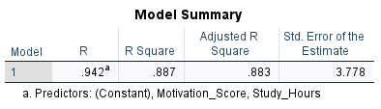

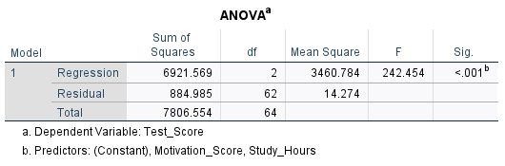

The ANOVA table provides two sources of variance and calls them Sum of Squares: Regression sum of squares and Residual sum of square. The Regression part shows the information, and the Residual part shows noise or unknown information. We want a high information to noise ratio (also known as signal to noise ratio). The higher this ratio, the more likely our model will be statistically significant and meaningful. In this ANOVA table, we can see that F = 242.454 and is statistically significant (p < 0.05). So, our regression model is statistically significant. The F value is calculated as the ratio of mean sum of squares of the regression to residual values (3460.784 / 14.274 = 242.454).

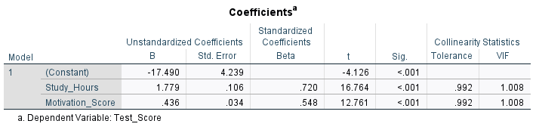

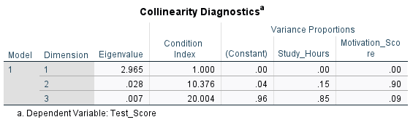

Interpretation

In this research, we aimed to explore the relationship between the number of hours students dedicate to studying and their academic motivation with their test scores. To investigate this question, we selected a random sample of 65 students and collected data on the hours students spent studying, their motivation scores from a reliable and valid questionnaire, and their test scores.

The results of the multiple regression analysis revealed that both study hours and motivation significantly influence test scores (F = 242.454, p < 0.05). The adjusted coefficient of determination, R²=0.883, shows that approximately 88% of the variation in test scores is explained by study hours and academic motivation. This suggests a strong relationship, emphasizing the impact of dedicated study time and academic motivation on school performance.

These findings underline the importance of consistent study habits in achieving higher test scores and encouragement from parents, teachers, and other stakeholders in a student’s education. These insights offer valuable guidance for both students and educators, demonstrating the significance of strategic time management and motivation in enhancing academic outcomes.

